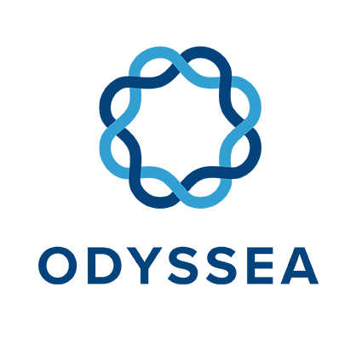
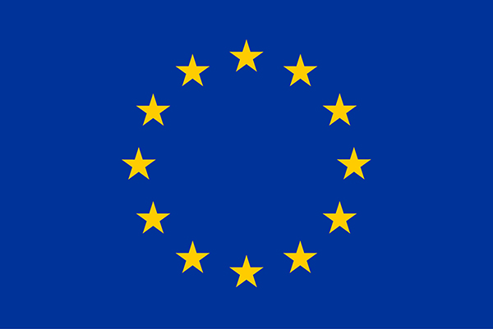
Operating a network of integrated observatory systems in the Mediterranean Sea

ODYSSEA General Assembly: Status, Challenges & Next Steps
Two years (or to be exact 30 months) into the project

Author(s): Simon van Dam; Bracha Ehrman; Raanan Boral
Work Package Number: 12
Work Package Title: Project Management

This project has received funding from the European Union’s Horizon 2020 research and innovation programme under grant agreement No 727277
ODYSSEA Project Information
Project full title | ODYSSEA: Operating a network of integrated observatory systems in the Mediterranean Sea
Project acronym | ODYSSEA
Grant agreement number | 727277
Project coordinator | Georgios Sylaios, DUTH
Project start date and duration | 1st June 2017, 54 months
Project website | http://odysseaplatform.eu/

PROPRIETARY RIGHTS STATEMENT
This document contains information, which is proprietary to the ODYSSEA consortium. Neither this document nor the information contained within may be duplicated, used or communicated except with the prior written permission of the ODYSSEA coordinator.

Setting the scene for the partner meeting
As we all know by now, ODYSSEA intends to develop, operate and demonstrate an interoperable and cost-effective platform that fully integrates networks of observing and forecasting systems across the Mediterranean basin, addressing both the open sea and the coastal zone.

In the DoA, we have stated that the ODYSSEA project with its user-centered approach is designed around four main phases: (A) Preparatory Actions (WP1 – WP3), (B) Data Collection (WP4 – WP5), (C) Generating Services (WP6 – WP8) and (D) Impact Generation (WP9 – WP12). In practice there are really three main interrelated main activities: (A) Setting up and operating the observatories (WP2, WP4 – WP5), (B) Developing the platform (WP3, WP6 – WP8) and (C) Ensuring the uptake of the results by a large audience in general and Blue Growth in particular (WP9 – WP12). Put it otherwise, these three main activities are the data input (A), processing and information output (B) and use (C).

In the first half of the project (we are exactly half-way), for each of these three main activities, we have been working in separate tracks. However, it is now time that we integrate the various activities and tracks into one operational platform. The models, the sensors, the algorithms and back-end of the platform should be integrated and synchronized in such a way that it will provide the services that our many end-users are interested in and would be willing to pay for in due time.

So, the integration of our various activities is one of the two main themes of this partner meeting. The second main theme is the preparation for sustainability. In order to achieve this, we would like to introduce a paradigm shift: instead of seeing ourselves as a project (with a beginning and an end), we should regard ourselves in a start-up stage and the grant as the seed-investment. The integration and subsequent demonstration of the platform will be the necessary condition to attract additional funding, either through sales to customers or otherwise. We will be discussing this as well at length.

At the end of the meeting, we hope that we all know what needs to be done in the next 6 – 12 months, while having obtained significant awareness and understanding how each activity either impacts or is impacted by other activities. Since all activities are interrelated, we have decided not to have any break-out meetings. We also encourage you to prepare questions as asking the right questions may be more important than providing answers. Don’t take anything for granted and bear in mind that everything is related to everything else. In short, even if you think that a particular topic is not related to you, so it doesn’t matter whether you understand it or not, this is absolutely wrong, at least at a high level.

Key Message for the Tangier Meeting: How to Turn ODYSSEA Project into a Sustainable Operation

ODYSSEA General Assembly Meeting
Date: October 29-31, 2019
Venue: Movenpick Hotel, Tangier, Morocco

AGENDA
Tuesday, October 29, 2019
Timing | Topic | Moderator(s) | Comments/Deliverables
08:30 - 09:00 | Registration
09:00 - 09:05 | Welcome & logistics | Georgios & Houssine
09:05 - 10:00 | Objectives of Partner Meeting in Tangier: Update current status, challenges and next steps | Georgios & Simon vD
Each component is allocated adequate time for presentation and discussion | Topics reflect the main components of the ODYSSEA initiative | Moderators (in bold) are the designated leaders in each “block”, yet all other involved partners are expected to present their contribution. | Presentations are expected to last up to 30 minutes and should be in a merged format integrating all involved partner contributions in accordance with instructions provided by Block leaders. Each block leader is responsible to merge contributions from all members.
10:00 – 11:00 | Sensors  Gliders & Static Systems  Status  Challenges  Next Steps | Laurent, Kim, Sergio | Gliders deployment schedule and next steps  Static systems – deployment, development level, next steps  Microplastic sensor (patent and new developments)  Deployment, where/why  Technical/Scientific issues/MPS Patent
11:00-11:15 | Coffee Break
11:15 – 13:00 | Models  Status  Challenges  Next Steps | Ghada, Katerina, Adelio, Nikos, Lorinc | Report current status; Technical issues related to models and interfaces; Timetable for model integration; Link model outputs to services and products;  Challenges & Next Steps
13:00- 14:00 | Lunch Break
14:00 – 16:00 | ODYSSEA Observatories  Status, Challenges and Next Steps  (Thracian Sea, Valencia, Adriatic) | Raanan/Daniel/Slim | State of deployment preparation, Modelling capacity, Stakeholder and End-User engagement, Operational team readiness, Capacity building
16:00 – 16:15 | Coffee Break
16:15 – 17:30 | ODYSSEA Observatories  Status, Challenges and Next Steps  (Al Hoceima, Gökova, Israel, Gabes Gulf, Nile ROFI, Algeria) | Raanan/ Daniel/Slim | State of deployment preparation, Modelling capacity, Stakeholder and End-User engagement, Operational team readiness, Capacity building
Wednesday, October 30, 2019
Timing | Topic | Moderator(s) | Comments/Deliverables
09:00 – 11:00 | Platform  Status  Challenges  Next Steps | Nicolas G., Simon K, Assaf S., | Where we are: Current/Future Platform Versions; Platform Transfer to the Data Centre; Integration of Modeling data; Integrate any new model into the platform - Platform scalability; Integrate glider data on the platform; On-line RT data transfer from Alseamar; Establish data flow Alseamar/CLS; Link algorithms to the platform,  Challenges & Next Steps
11:00 – 11:15 | Coffee Break
11:15 – 13:00 | ODYSSEA Platform Services  Status  Challenges  Next Steps | Laura, Claire, SvD, Lorinc, Mercedes, Georgios | The use of Platform for:  Education, Coastal erosion studies, Jelly fish blooms, Fisheries, Eutrophication, Mussel farms, Fish farms, Ballast water
13:00 – 14:00 | Lunch Break
14:00 – 15:30 | Business Cases | Claire, Laura, Lorinc, Simon vD | Presentation of Canvas exercise and product sheets
15:30 – 15:45 | Coffee Break
15:45 – 17:15 | Business Cases | Claire, Laura, Lorinc, Simon vD | Presentation of MULO exercise

Thursday, October 31, 2019
Timing | Topic | Moderator(s) | Comments/Deliverables
09:00 – 10:00 | Potential Future ODYSSEA Legal Structures | Meny Broid
10:00 – 11:00 | Increasing Budget | Simon vD
11:00 – 11:15 | Coffee Break
11:15 – 13:00 | Citizen science mobile application | Simon K. | ODYSSEA API
13:00 – 14:00 | Lunch Break
14:00 – 15:00 | GPDR Issues | Meny Broid | Q&A regarding GPDR and the platform
15:00 – 17:00 | Milestones, Reporting, Administration | Bracha, Simon vD, Menelaos

Wishing us all a successful and enjoyable ODYSSEA Meeting!

