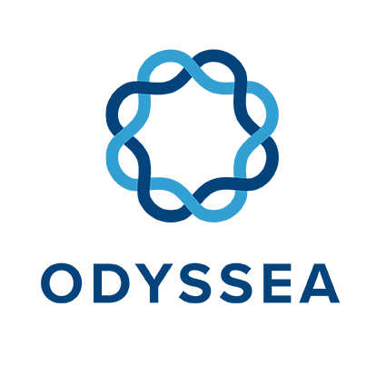
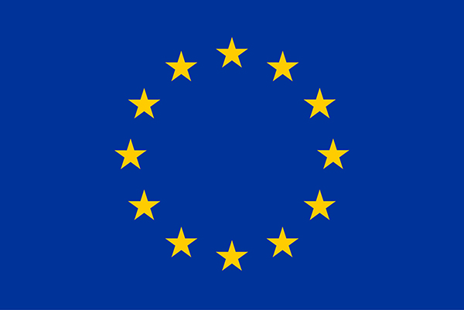
Operating a network of integrated observatory systems in the Mediterranean Sea

ODYSSEA Status & Challenges
One year into the project

Author(s): Simon van Dam; Bracha Ehrman; Raanan Boral; Baruch Lionarons
Work Package Number: 12
Work Package Title: Project Management

This project has received funding from the European Union’s Horizon 2020 research and innovation programme under grant agreement No 727277
ODYSSEA Project Information
Project full title | ODYSSEA: Operating a network of integrated observatory systems in the Mediterranean Sea
Project acronym | ODYSSEA
Grant agreement number | 727277
Project coordinator | Georgios Sylaios, DUTH
Project start date and duration | 1st June 2017, 54 months
Project website | http://odysseaplatform.eu/

PROPRIETARY RIGHTS STATEMENT
This document contains information, which is proprietary to the ODYSSEA consortium. Neither this document nor the information contained within may be duplicated, used or communicated except with the prior written permission of the ODYSSEA coordinator.

Table of Contents
2 Achievements and Challenges 7
Table 1: List of milestones for M1 – M24 7
Table 2: Deliverables for M1 – M23 (all submitted on time) 7
Table 3: List of milestones for M24 – M39 7
Table 4: Deliverables for M24 – M36 8
3 Challenges per Work Package 9
3.1 Work Package 4: ‘Operational Modelling’ 9
3.2 Work Package 5: ‘In-situ Monitoring’ 11
3.3 Work Package 6: Platform Development, Operation and Maintenance 12
3.4 Work Package 8: ODYSSEA End-user Services 13
3.5 Work Package 9 ‘End-users and policy makers involvement’ 14
3.6 Work Package 10: Capacity Building In North African Countries 16
3.7 Work Package 11: Dissemination, Communication and Visibility 9

ODYSSEA Work Package Leaders Meeting Athens
Date: May 14, 2019
Venue: CLS Offices
Toulouse, France

In the DoA, we have stated that the ODYSSEA project with its user-centered approach is designed around four main phases: (A) Preparatory Actions (WP1 – WP3), (B) Data Collection (WP4 – WP5), (C) Generating Services (WP6 – WP8) and (D) Impact Generation (WP9 – WP12). However, in practice there are really three main interrelated main activities: (A) Setting up and operating the observatories (WP2, WP4 – WP5), (B) Developing the platform (WP3, WP6 – WP8) and (C) Ensuring the uptake of the results by a large audience in general and Blue Growth in particular (WP9 – WP12). Put it otherwise, these three main activities are the data input (A), processing and information output (B) and use (C).
For each of these main activities, we are about to reach a milestone: (A) the first observatories are about to be set up; and (B) version 1 of the platform has just been launched and version 2 is being developed. For version 1 and 2, we are integrating the applications that we selected last year. This is (C) the use of the output of the platform and we are already identifying demand. Obviously, these three milestones are interrelated.
The purpose of the work package leader is to ensure that we are indeed fully ready for these milestones and that the integration, the trickiest part of the project, is still maintained. Ahead of the meeting, we will distribute a small number of documents that will be the base of our discussions. Regarding the format of the meeting, the objective is to ensure that a constructive discussion and analysis will take place of the current status of the main activities (before lunch) and steps to be taken necessary for meeting the mentioned milestones and beyond (after lunch).
On purpose, we have left the agenda rather open in order to facilitate and encourage the frank and open discussions that are required to make progress in the main activities. We are aware that we have a number of unknowns in the equation that we need to solve, but we strongly believe that our meeting will allow us to make (significant) progress here. Therefore, there will be few presentations, if any at all, but lots of discussion moderated mainly by the Agora team. Raanan will moderate the discussion related to the observatories, Bracha will moderate the discussion related to the platform and Simon will moderate the discussion related to the use and business cases. We are using the same set-up as we did in Athens last year and the results were very satisfactory, hence we would like to apply the same set-up in this case as well. It time allows, we will discuss the capacity building as well – this discussion will be moderated by Menelaos (despite not being part of Agora).
Timing | Topic | Moderator | Comments/Deliverables
09:00 - 09:30 | Objectives Leader Meeting | Simon vD
09:30 – 10:30 | Current Status Project | Georgios | Open discussion
10:30 - 11:00 | Coffee break
11:00 - 12:00 | Current Status Platform | Bracha | Open discussion
12:00 - 13:00 | Current Status Observatories | Raanan | Open discussion
13:00 - 14:00 | Lunch
14:00 - 16:00 | Recommendation Experts on the Period Report and Review | Agora Team | Open discussion
16:15 - 16:45 | Coffee break
14:00 - 16:00 | Next steps | Agora Team | Open discussion
17:30 – 18:00 | Wrap Up Meeting | Agora Team
20:00 - 22:00 | Dinner

Wishing us all a successful and enjoyable ODYSSEA Meeting!

Achievements and Challenges

Table 1: List of milestones for M1 – M24

MS # | Milestone name | Related WP(s) | Date | Date | Verification
MS1 | Workshop with representatives of EU funded projects | WP13 | Mar 2018 | M10 | D13.3
MS2 | Model Observatories established | WP2, WP4 | May 2018 | M12 | D2.3
MS3 | Microplastic sensors integrated into develogic’s surface instrument package and modular seafloor lander and Alseamar glider technology | WP5 | Nov 2018 | M18 | D5.2
MSx | Launch of ODYSSEA Platform V1 | WP6, WP7, WP8 | Dec 2018 | M19 | ??

Table 2: Deliverables for M1 – M23 (all submitted on time)
# | Deliverable name | WP # | Lead # | Type | Dis. level | Del date
D12.1 | Protocol Kick-off meeting | 12 | DUTH | R | PU | Jun 2017 | M1
D12.2 | Establishing governance structure | 12 | DUTH | R | PU | Jun 2017 | M1
D2.1 | Establishment of ODYSSEA Model Observatories | 2 | DUTH | OTH | CO | Oct 2017 | M5
D1.1 | H - Requirement No. 1 | 1 | DUTH | R | CO | Nov 2017 | M6
D1.2 | POPD – Requirement No. 2 | 1 | DUTH | R | CO | Nov 2017 | M6
D11.1 | Communication plan | 11 | BLIT | R | PU | Nov 2017 | M6
D11.2 | A project identity and specific project website | 11 | BLIT | Dec | PU | Nov 2017 | M6
D13.1 | Inventory of existing data sources and gaps inventory | 13 | Sapienza | R | PU | Dec 2017 | M7
D2.2 | End-users needs & requirements per Observatory | 2 | DUTH | R | CO | Jan 2018 | M8
D3.1 | ODYSSEA platform architecture guidelines | 3 | Hidromod | OTH | CO | Jan 2018 | M8
D13.2 | Data post-processing procedures report | 13 | Sapienza | R | PU | Feb 2018 | M9
D6.2 | Platform architecture and design document | 6 | CLS | OTH | CO | Feb 2018 | M9
D13.3 | Recommendations & proposals for new regulatory regimes | 13 | Sapienza | R | PU | Mar 2018 | M10
D3.2 | Data Management Plan for collected data | 3 | Hidromod | OTH | PU | Apr 2018 | M11
D2.3 | Specifications for monitoring & modelling per Observatory | 2 | DUTH | OTH | CO | May 2018 | M12
D2.4 | Plugins for data transfer and intercommunication | 2 | DUTH | OTH | CO | Jul 2018 | M14
D7.1 | Requirements specification document | 7 | Technion | OTH | CO | Jul 2018 | M14
D7.2 | Sample Datasets for development | 7 | Technion | OTH | CO | Oct 2018 | M17
D10.1 | Training material for workshops | 10 | RAC-SPA | OTH | PU | Nov 2018 | M18
D3.3 | Updated Data Management Plan for collected data | 3 | Hidromod | OTH | PU | Nov 2018 | M18
D4.1 | Report: Experimental operation of models per Observatory | 4 | FORTH | R | CO | Nov 2018 | M18
D5.1 | Technical report sensor development and integration | 5 | Alseamar | R | CO | Nov 2018 | M18
D12.3a | Midterm report | 12 | DUTH | R | PU | Nov 2018 | M18
D6.1 | ODYSSEA Platform system requirements document | 6 | CLS | OTH | CO | Feb 2019 | M21
D5.2 | Observatory governance structure and organization | 5 | Alseamar | OTH | CO | Mar 2019 | M22
D9.1 | Map of platform data & services to targeted end-user needs | 9 | WCMC | R | CO | May 2019 | M24

Table 3: List of milestones for M24 – M39
MS # | Milestone name | Related WP(s) | Date | Date | Verification
MS2 | Model Observatories established | WP2, WP4 | May 2018 | M12 | D2.3
MS3 | Microplastic sensors integrated into develogic’s surface instrument package and modular seafloor lander and Alseamar glider technology | WP5 | Nov 2018 | M18 | D5.2
MS4 | Validation and refinement of algorithms | WP7 | Jun 2020 | M37 | D7.3
MS5 | ODYSSEA Platform Prototype | WP6 | Aug 2020 | M39 | D6.3

Table 4: Deliverables for M24 – M36
# | Deliverable name | WP # | Lead # | Type | Dis. level | Del date
D9.1 | Map of platform data & services to targeted end-user needs | 9 | WCMC | R | CO | May 2019 | M24
D8.1 | Report on Functionality assessment | 8 | Deltares | R | CO | Nov 2019 | M30
D11.3 | A mix of communication tools | 11 | BLIT | Dec | PU | May 2020 | M36
D12.3b | Midterm report | 12 | DUTH | R | PU | May 2020 | M36
D4.2 | Report of models validation results in each Observatory | 4 | FORTH | R | CO | May 2020 | M36
D5.3 | Evaluation of the operation of the Model Observatories | 5 | Alseamar | R | CO | May 2020 | M36
D7.3 | Reference algorithms | 7 | Technion | OTH | PU | Jun 2020 | M37
D6.5 | ODYSSEA Platform prototype | 6 | CLS | OTH | PU | Aug 2020 | M39

Challenges per Work Package

Work Package 4: ‘Operational Modelling’

1. What is the current status of your WP? What has already been achieved?
- WP4 began in March 2018 (M10). Task 4.1 “Experimental operation of models in each Observatory” has been completed in November 2018 (M18) with the submission of D4.1 (Task Leader DUTH). We are currently in Task 4.2 “Models testing and calibration in each Observatory” (M18-M30, Task Leader: AUTH).
- In Task 4.1, a significant part of the work performed comprised of the configuration and set-up of the 2 interface tools/platforms available to the consortium (Delft-FEWS and Hidromod’s AQUASAFE) able to link and operationalize the chain of numerical models to be implemented at ODYSSEA Observatories, import the required initial and boundary conditions and interface the Observatory system with ODYSSEA platform.
- Both interface systems have been configured for the Thracian Sea Observatory running Delft3D-FLOW in operational forecasting mode and their relative performance has been assessed based on a set of predefined criteria considering the general performance of each system, their pre-processing and post-processing capacity, and their capability to assimilate in-situ data and publicize results. A decision was reached to apply both systems at selected Observatories, as follows: three Observatories will be run using the Aquasafe interface (Israel, Algeria and Morocco) and five Observatories with the Delft-FEWS toolkit (Turkey, Greece, Egypt, Tunisia and Spain). In the Northern Adriatic, the numerical models already operating will also be linked through the Delft-FEWS system.
- Pilot model runs of Delft3D-FLOW, Delft3D-WAVE (SWAN), MEDSLIK-II, the ecosystem model Ecopath and the mussel biomass model MusselGrow have been performed for ODYSSEA Observatories testing also the step-wise processes for the configuration, set-up, import of initial and boundary conditions and performing preliminary runs.
- While by the end of Task 4.1 only the hydrodynamic model Delft3D-FLOW has been incorporated into Delft-FEWS and AQUASAFE tools/systems (all other preliminary model runs had been performed independently), currently the hydrodynamic and WAVE models (Delft3D-FLOW and SWAN) are linked to both tools/systems.
- An Observatory-Tech mailing list has been established including the technical/modelling personnel from each Observatory and representatives from FORTH, DUTH, Deltares and Hidromod to facilitate the implementation of Delft-FEWS and AQUASAFE as well as the numerical models at Observatory level and solve all relevant technical/modelling issues. The team has held its first meeting discussing FEWS and AQUASAFE implementation and the 1st version/implementation of the hydrodynamic model at Observatories. The second meeting of this group is planned in the next month with the release of the 2nd version of the hydrodynamic (and wave) models. These model versions form the basis for the cal/val to be performed in cooperation with Observatories personnel.
2. What are the challenges that you foresee for the next 6 – 12 months within your WP?
- The (2) key challenges for WP4 over the next 12 months are:
  - To schedule (operationalize) and run in forecast mode the hydrodynamic, wave and water quality models for all 9 Observatories. This will kick-off the forecasting capabilities/services at Observatory level, regardless of the (initially poor to medium) quality of results/forecasts.
  - Calibrate models for each Observatory. Ad-hoc calibration/validation protocols and metrics will be defined on a model basis. The performance of all models will be evaluated in hindcast mode, using available historical observations (for sea surface temperature, salinity, currents, Chl-a, species biomass data, fisheries catches etc.). The procedure is expected to differ among models and observatories depending on data availability.
  - For the implementation of ECOPATH models in the 3 selected Observatories (Turkey, Morocco, Egypt) the next period is crucial for advancing from pilot experimental runs to obtaining meaningful results, depending on the quality/reliability of data obtained (for Biomass, P/B, Q/B, EE, Diets, Catches).
3. What inputs are you expecting from other WPs and when?
- Since we are now entering the second year of the ODYSSEA project, and the deployment of in-situ sensors in about to take place, we expect local in-situ data from the Observatories, which will be used for cal/val purposes and be integrated in the modelling module of the Observatories. All parameters monitored will be extremely helpful for our models. For ecosystem modelling in particular, which is data-starved and driven, any information regarding chlorophyll and temperature will be incorporated.
4. What outputs are you expecting to provide to other WPs and when?
- We expect to provide (model) outputs to be (test-) uploaded to the ODYSSEA platform, when models are in operational forecasting mode in Observatories, by the end of June.
- We also expect to provide necessary input (output model variables) for business models and services (WPs 8 & 9).

Work Package 5: ‘In-situ Monitoring’

1/ Status of WP
Technical

For Alseamar equipment
- µP sensor received
- work test bench ongoing
- Ocean test to follow
- Training of observatory leader done
- Shiping of the 1st glider done
- Shipping of the second glider by summer

For develogic equipement
- µP sensor received
- work test bench: ??
- Training of observatory leader : programmed in July
- Shiping of equipment by ??

2/ Foreseen challenges
- Shipping of equipment (who pays for what?)
- Readiness of observatories
- Data format and integration to platform & models
- Glider mission planning (dates and trajectory)
  - 90% done with Grece
  - 40% done with Marrocco
  - 0% done with Israel (but glider will be there in 1 year time)
  - 0% done with Algeria (but glider will be there in 1 year time)

3/ Inputs with others WP
- Data flow (from observatories to platform): work started in Lisbon meeting

4/ outputs
- Data flow (from observatories to platform): work started in Lisbon meeting

Work Package 6: Platform Development, Operation and Maintenance

1. What is the current status of your WP? What has already been achieved?

- The D6.1 has been delivered on time
- All components are pushed on a GitShare a distribute version-control system https://gitshare.cls.fr/odyssea
- All components have been ported to docker technology
- The machine has been bought in December 2018 for 34K€ and will be set up for beginning of Summer
- The platform V0 is running on each partners premise/ the V1 is integrated on CLS premise on a temporary machine
  - There were a lot of interaction with Edisoft, Hidromod, Bluelobster to make some modifications to allow the integration monitoring
- The design to integrate algorithms has been written
    - https://groupcls.sharepoint.com/:w:/s/odyssea/EYqXWDOLQfxKr2uz3ngxFFoB1p11vAk97gNaNU61aMO5Iw?e=631EZB
    - Work with the WP7 members to define how to integrate algorithms into ODYSEA platform

2. What are the challenges that you foresee for the next 6 – 12 months within your WP?

- Open the V1 to the partners and to the end users (ASAP)
- Deploy the V1 on the new machine bought in December (For the summer)
  - We have to port all component on K8S technology (Cloud ready)
- Integrate TRIX as new product into the platform
- Integrate the output from observatories models
- Integrate first output from observatories sensors
- Prepare the V2 with an interactive mode between end user and process launched
  - The first one could be the DataBroker that will allow merging In -Situ data and gridded data
  - Who will develop the DataBroker ?

3. What inputs are you expecting from other WPs and when?

o TRIX algorithms compliant with CLS requirements (before Summer)
o Output from observatories (ASAP)
o Help from WP8 to validate the platform, the contents, etc …

4. What outputs are you expecting to provide to other WPs and when?

Work Package 8: ODYSSEA End-user Services

The status of WP8 will be rather short as most effort from our side is currently being put into other WPs, e.g. modelling (together with WP4), citizen science related activities (together with Claire, Thales (WP7)), business cases (WP9). The first deliverable will be due in November of this year (D8.1: Report on functionality assessment).

1. What is the current status of your WP? What has already been achieved?

Regular meetings have been set up. During the kick-off meeting last year, the roadmap had been discussed and agreed on with all participants of this call. During the regular WP8 calls as well as attending WP9 calls it became clear that a closer collaboration between WP8 and WP9 should take place. Therefore recently, bimonthly WP8/9 collaboration calls have been set up. The main objective is to make progress on the first two tasks of the WP (8.1 – Platform assessment and 8.2 – Ecosystem evaluation). In addition, WP8 actively participates in the definition of end-user services (according to business cases) together with WP9.

2. What are the challenges that you foresee for the next 6 – 12 months within your WP?

The validation and testing of the platform and models heavily rely on the progress made in modelling (WP4), algorithm development (WP7) and business cases (WP9). Getting all necessary information on time will be a challenge. All but Task 4.4 have already started working on their deliverables according to the work plan. Most of them are due at a much later stage (not in the next 6-12 months).

3. What inputs are you expecting from other WPs and when?

- From WP6: Reliable working platform incorporating latest available data sources (model outputs, ODYSSEA sensor data). This will allow us to start the platform validation. Last September the platform V0 was released and tested during the summer school. The release of the new platform version is scheduled.
- From WP4: The first modelling components are running operationally in all observatories. This will allow us to start the ecosystem assessment and model validation. (by mid- 2019)
- From WP7: First algorithms are implemented and producing “generated ODYSSEA services”. This will allow us to start the validation of algorithms. (by mid-2019)
- From WP9: User needs and business cases are defined. This will allow us to validate the services in view of the user requirements.

4. What outputs are you expecting to provide to other WPs and when?

- To WP6: Feedback and guidance on platform development: functionality, gaps, adequacy of output, reliability etc. (done during the first summer school, will be done once V1 is released)
- To WP4: Deltares actively participates in the model setup. The ecosystem evaluation using the ODYSSEA platform will provide insights on the gaps, adequacy of output, and reliability of the ODYSSEA models. Data assimilation and tools developed in WP8 will be used and applied in task 4.4 (M42). (ongoing)
- To WP7: Guidance on the selection of algorithms to be developed and feedback on the functionality (ongoing)
- To WP9: Help to translate user needs into technical platform specifications and services definition. (ongoing)

Work Package 9 ‘End-users and policy makers involvement’

1. What is the current status of your WP? What has already been achieved?
- The establishment of partnerships with potential end-users and identification of key user needs is under way at the Observatories. Each Observatory has identified at least one key sector of interest, and several partnership agreements have already been set up, or are in the process of being set up.
- At the regional policy level, the UNEP/MAP-IMAP process has been identified as the key policy process that ODYSSEA could support, and engagement is progressing well.
- Efforts to collaborate with the European Environment Agency on linking up ODYSSEA and the Marine LitterWatch App have been renewed, and the EEA has expressed interest in taking this collaboration forward.
- Several user engagement workshops have already taken place in the Observatory countries. These efforts will be intensified once the Platform is ready to be shared and tested externally. The ODYSSEA Summer School in 2018 provided a first opportunity for user validation of the Platform prototype.
- A mapping exercise has been conducted to provide a status report on service development and user need identification, and alignment between the two (Deliverable 9.1). This information is to be updated regularly with increasing level of detail moving forward to support service development and user engagement. It has already initiated conversations between WP7, WP8, WP9 and Observatory leaders about respective information requirements.
- ODYSSEA Business Strategy: preliminary ideas have been developed.
- ODYSSEA App: Draft specifications for the App have been developed. These are to be refined by the end of June in order to start the process of conversion into a working App. A timeline for the development, testing and validation of the App by November 2020 (M42) has been agreed between SPNI, Blue Lobster and WCMC.
2. What are the challenges that you foresee for the next 6 – 12 months within your WP?
- The key challenge for WP9 over the next 6-12 months will be to effectively liaise between Observatory leaders and WP6/7/8, so as a) to help the Observatory leaders refine the user needs, promote the Platform and services to their end-users, and find clients for ODYSSEA services, and b) to help the Platform and service developers get the information about user needs and user validation feedback they need to produce the services.
- Another key challenge will be taking the development of the ODYSSEA Business Strategy forward, building business cases and finding potential clients.
3. What inputs are you expecting from other WPs and when?
- Updates from WP6/7/8 on a) services under development, and b) what they need to know about user needs in order to develop the services
- Updates from Observatory leaders about a) user needs, and b) what information about the services they need to facilitate engagement with end-users
- ODYSSEA App: testing and feedback October to December 2019 (following presentation at General Assembly)
4. What outputs are you expecting to provide to other WPs and when?
- Deliverable 9.1 ‘Mapping platform data and services to targeted end-user needs’ to be submitted to the EC by end of May (draft currently out for review by project partners)
- Regular updates of ‘services-user needs map’ to support service development and end-user engagement; frequency of updates to be determined and adapted to the needs of WP6/7/8 and Observatory leaders
- Feedback for platform developers from user validation workshops (to be confirmed where and when these will take place)
- ODYSSEA App: fully designed version to be presented at General Assembly for testing, feedback and revision until the end of the year

Question for Project Coordinators:
Could I please request clarification on Deliverable 9.4 ‘Reports of thematic workshops’ (public, due M54)?
- Which workshops does this refer to?
- Linked to this, who is expected to prepare them?
- How many reports are we expected to submit?
- What is the purpose of these reports?

Work Package 10: Capacity Building In North African Countries

- What is the current status of your WP? What has already been achieved?
Training activities that have been achieved during the first 18 months of ODYSSEA are detailed in Deliverable D10.1 titled “Training material for workshops”. This deliverable has been accepted by the ERA Review committee.
In 2019, the following training workshops are already planned:
- Training workshop on preparation, operation and maintenance of underwater gliders for scientific missions – ALSEAMAR premises, 8-12 April 2019 – already achieved. Houcine NIBANI, Elyass NIBANI, Ben Younès ABDELALOUI (3 from Morocco), Nikolaos KOKKOS (GR), Roy KOSOVER (IS) and Slim GANA (SPA/RAC) have attended this training workshop. A Glider user guide has been delivered during the training.
- Training workshop on the Modular Seafloor lander and Surface Monitoring system, to be held in DEVELOGIC premises, Hamburg, from Monday 8 July to Friday 12 July 2019.
Training on SWAN (Simulating Wave Nearshore) have been discussed but no date has been set.
The possibility of a summer school in Tunisia has been mentioned but no date has been set.

- What are the challenges that you foresee for the next 6 – 12 months within your WP?
More pro-activity, reactivity and involvement from the observatory’s leaders, especially North Africans.
We have recently (15 March 2019) carried out a survey in order to have an update on the observatory’s implementation and on the needs in term of capacity building to support the operational implementation of the observatories.
After 2 reminders and the help of Menelaos who sent another reminder to those who haven’t answered, it took 1 month to obtain 8/9 replies.
The results if this survey is attached. Only very few answers are relevant

- What inputs are you expecting from other WPs and when?
To involve us (WP10) in the preparation and management of the future trainings curriculum.

- What outputs are you expecting to provide to other WPs and when?
We will contribute in the curriculum and our contribution will be based on the capacity needs expressed by the North African Countries. We will propose participation of persons that will be able, according their background and position, to ensure the sustainability of their country observatory.

SURVEY ON OBSERVATORIES IMPLEMENTATION PROGRESS AND CAPACITY BUILDING NEEDS
# | Observatory | Contact | Observatory implementation activity update | Expression for capacity building needs
1 | Turkey  Gökova observatory | YELDA AKTAN TURAN <yaktan@istanbul.edu.tr> | The anchoring point in the specified settlement area of surface instrument was determined. Also, on 8-9 April we will have a meeting with the host (small marina and sailing academy), and will discuss on “equipment hosting agreement” (Raanan will send us DUTH’s protocol with oil platform as a sample protocol hopefully it will be before 8 April). They are one of the potential end-users.  In addition stakeholders and potential end users workshop will be held in the Gökova Region (Gökova, Muğla) on 29-30 April for expanding the circle of the end user. This workshop will address a wide range of different groups (governmental attendance, NGOs, business sector, scientists) and public. In this way, we hope that we contribute to increase the capacity building of Gökova observatory with new collaborations. | With regard to the training about Sensors, we had determined our technical staff, Mr. Dr. Cumhur H. Yardımcı. Any training date in June is OK for us, please just let us the date.
2 | Spain  Valencia | Mercedes De Juan Muñoyerro <mdejuan@fundacion.valenciaport.com> | Due to the availability of monitoring devices in the area of the Valencian Observatory, VPORTS has proposed to develop common procedures and monitor alien invasive species (AIS) in port areas.  Ports are a well-recognized key vector for the introduction of these harmful species. However, there a significant lack of information related to the transmission of AIS in the ballast water.  The objective is to develop standard procedures in the Mediterranean Sea for analyzing the transmission and impact of these species.  VPORTS has presented to the management team a workplan that has been transmitted to the EU project officer for approval.  At the present time, we are waiting for the approval confirmation of the Commission for going ahead with the Ballast water roadmap.
3 | Northern Adriatic | Marco.Zavatarelli <Marco.Zavatarelli@unibo.it> | Work is progressing satisfactorily with respect to the implementation of the operational coupled physical biogeochemical model.  Concerning the monitoring activities contacts have been established with some potential users of the microplastic sensor. | To be defined.
4 | Thracian Sea | Georgios Sylaios, gsylaios@env.duth.gr  Nikolaos Kokkos, nikolaoskokkos@gmail.com | Static Systems: Deployment point for Lander has been determined at the oil platform of Energean Oil and Gas SA. Glider : the mission of gliders at the Thracian Sea has been approved by Greek Authorities and a licence was issued. Modeling : FEWS and Delft3D for the Thracian Sea are running operationally. SWAN is now being connected. As soon as these two models are ready, we could provide training to Observatory technical staff.  Connection to end-users: We are waiting for the all problems to be resolved with the platform to start discussion with end-users. | Nikos Kokkos will participate at the training session of Alseamar on glider usage. He will also participate at the training on lander use at Hamburg.  Regarding other needs, we discussed it with Nikos. We don't feel we need training at the moment. However, if other partners need, we could provide expertise.
5 | AGIR  Morocco | NIBANI Houssine  agirnibani@gmail.com | For the surface modular, the choice of anchoring will be made either at the marina of the port of Alhoceima or at the port of Tala Youssef.  A meeting with the Maritime Fisheries Delegation and INRH is scheduled for May for the implementation of the operation.  Similarly, in the case of the anchoring of the depth module, it will be anchored in a rocky reef at a depth between 30 and 60 metres, the anchoring point in a rocky area that will be protected against trawler activity, it will be defined jointly with the Maritime Fisheries Delegation and the INRH during the month of May for the implementation of the operation | As far as sensor training is concerned, we have designed ilyass nibani and another person to be designated between AGIR and INRH. They will be available for this training according to your preferences.  Data collection needs and data handling.
6 | NSV - Algeria | Arslan CHIKHAOUI arslanchikhaoui@nsventures.net  Saïda LAOUICI BOUDJEMA ody.al@yahoo.com | Check with LauraFriedrich . Observatory implementation update has been done during the conference call between AC and Laura on 16 April. | - Our technical team (Younes BaHARI, Djamel Benmayouf & Amine Kabrane) takes part at AlSEAMAR training  - Arslan takes part at LCS workshop  - We recommended training session on Sciences diplomacy to link-up the project to policy & decision makers.  - We can provide expertise for other trainings connected to NSV expertise field
7 | RAED - Egypt | No answer
8 | ECOOCEAN - Israel |  | The location for deployment of the static sensor (surface unit) was approved for the off-shore Ashdod area fish cages at 80m depth. Additional current sensors will be purchased from the EU LAKSHMI project. The glider mission is being prepared by the Israeli Ocenographic and Limnological Institute. Work on operating the Aquasafe platform for the Israeli coast is in progress. The computer was purchased and setup.  Once the platform is ready and useful new data will be produced we will start the outreach to additional end-users | Roy Kasover participated in Alseamar workshop.  Itay Katzman and/or Assaf Ariel will participate in the Develogic workshop.  We would need the exact dates for the arrival of the static sensors in order to prepare together with the fish farms.  As far as we are concerned, the two workshops from Alseamar and Develogic are sufficient for now.  However, I remind that there is another planned (and stated in the grant agreement) hands-on marine workshop for the observatory managers, which we need to start preparing a detailed plan for. The aim of the workshop is to provide scientific and technical marine skills to the managers. The workshop is planned to take place in Greece, using a Greek vessel, during end of 2019 or beginning of 2020.
9 | ADDCNVS – Tunisia | Hekma ACHOUR  sophia-ac@hotmail.com | Following the recommendations of the stakeholders who attended the WG 2 on the ODYSEEA Platform and the setting up of the Observatory, it was decided for security reasons and optimization of data to change its location and move to southern gulf of Hammamet.  Nevertheless, we keep the same characteristics of depth. | Suggestions:  Do you think that an extra training session (on sensors and modelling data (like the one in Crete) could be planned in Tunisia, where more participants from north Africa could attend ?!  Some clarifications:  How long do you think the sea surface sensors could be deployed, and how often do we need to check them for maintenance.  Is the transfer for modeling automatically done between computer and the platform, if so what is the transfer frequency? If not, how long can we store the data before its manually transfer?  Is it possible to have 2 different persons, one handling the computer and the other handling the sensors?  Answers:  Q1: How long do you think the sea surface sensors could be deployed, and how often do we need to check them for maintenance?  A1: Based on my experience with in-situ oceanographic sensors used for monitoring water quality parameters in the Tunisian coastal shelf, I recommend to check the equipment and clean it from fouling each 2-3 months at least. Rob should give more details regarding the anti-fouling protection of the sensors during the training or by providing technical sheets. However, if your system is not fitted with the near real-time data transfer module, you should recover your data each two weeks and check that the sensors are functioning properly. If your system is fitted with the near real-time data transfer module, you will the receive, with the data, information about the sensors status.  Q2: I would like to know if the transfer for modelling is automatically done between computer and the platform, if so what is the transfer frequency ? If not, how long can we store the data before its manually transfer ?  A2: First, the expression “Transfer of modelling” is not appropriate. You will transfer water quality data acquired by the sensors to your computer. In your case, your surface station will record Temperature, Conductivity (Salinity), Dissolved Oxygen, Turbidity and Chl-A. Depending on the temporal variability of the phenomena that you would like to study and the capacity of the memory embedded in the surface station, you will choose the temporal resolution (each 10 or 30 min for example) and the transfer frequency (each 3, 6 or 12 hours for example). You have to check with ROB the capacity of the internal memory and what is the data transfer module that will be installed in your surface station.  Then, when you will decide, the data will be transferred from your computer to the Odyssea Platform.  Q3: Is it possible to have 2 different persons one handling the computer and the other one handling the sensors ?  Yes, it is possible to split the task related to data in 2 different activities:  - Data acquisition (by the surface station)  - Data management and analysis (on the computer). However, you can do other activities on your computer, as flow and waves modelling which is a completely different task.  You can appoint different (skilled) persons for each activity/task.

Work Package 11: Dissemination, Communication and Visibility

Website design and project identity

- The ODYSSEA communication plan has been delivered (D11.1). A Communications working group (CWG) has been established. The CWG hold regular meetings to ensure that the Communication Plan is implemented and the success of all communication activities are monitored in accordance with the plan. (Task 11.1).

The most recent CWG meeting was held in February 2019. The main actions resulting from the meeting included finalisation of the First ODYSSEA Project Newsletter, updated event and dissemination log for Period 2 of the project, translation of the main website content into French and Arabic (See section 3 below for more details), agreement of provisional date for the second ODYSSEA Summer School and the theme of the second ODYSSEA Newsletter (See Sections 3 and 4 below for more information).

- The ODYSSEA brand / identity has been designed, approved and implemented. It includes (Task 11.2) (D11.2):
  - Project logo
  - Project website (http://odyssea.eu)
  - Project deliverable template
  - Project presentation template
  - Project meeting minutes template
  - Frist project newsletter

- A number of materials / communication channels have been produced for dissemination to a variety of stakeholder groups (Task 11.3). These include:
  - A project flyer and banner presenting the projects main elements. They are both available in English, French and Greek and can be downloaded from the projects website at http://odysseaplatform.eu/project-information/project-graphics-and-templates/
  - 7 press releases have been issued and are available on the projects website (http://odysseaplatform.eu/press-releases/)
  - A blog has been implemented on the project website to disseminate all project news (http://odysseaplatform.eu/blog/)
  - An active and comprehensive, multilingual Social Media campaign has been established with activities in English, French, Greek, Spanish and Arabic.
  - The first project newsletter has been designed and distributed electronically to the ODYSSEA partners and their extended Networks, the ODYSSEA Social Media communities and it is available on the project website (http://odysseaplatform.eu/2019/02/12/first-odyssea-newsletter-creating-products-and-knowledge-for-the-mediterranean/).
  - As agreed at the last CWG Meting in February 2019, the project website has been updated to make the main project Homepage and Project Information Page available in French and Arabic:

French
http://odysseaplatform.eu/fr/home-fr/, http://odysseaplatform.eu/fr/project-information-fr/

Arabic
http://odysseaplatform.eu/ar/home-ar/, http://odysseaplatform.eu/ar/project-information-ar/

D11.3: “A mix of communication tools” is due in Month 36.

- Progress on delivering the 2 ODYSSEA Summer Schools (Task 11.4):
28 students, representing 10 countries from all over the Mediterranean and beyond attended the first ODYSSEA Summer school on Operational Oceanography for Science, Business and Society, to be held at the campus of the Akontisma Village Hotel, NeaKarvali, near Kavala, Greece, between September 3 and 12, 2018.
The programme provided training for oceanographers and engineers, young researchers, PhD candidates or professionals at the early stages of their professional carriers who are interested in learning to manage the available marine environment data to provide targeted and understandable information to the relevant end users. The first ODYSSEA Summer School introduced trainees to all stages of operational oceanography, contributing towards the Blue Growth of the Mediterranean Sea.
The training programme was well received by all delegates with most agreeing that the Summer School had clear objectives and material was well organised and presented (Figure 1.1a and b).
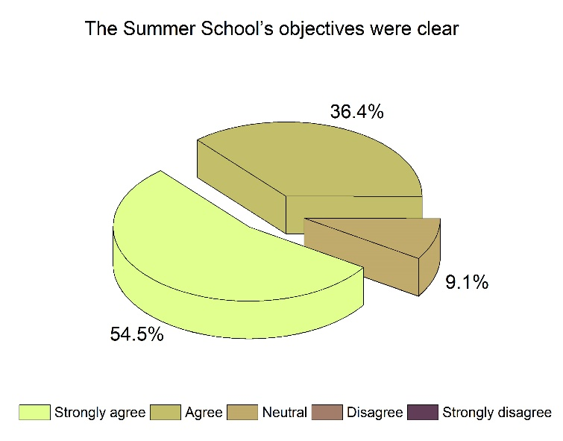 | 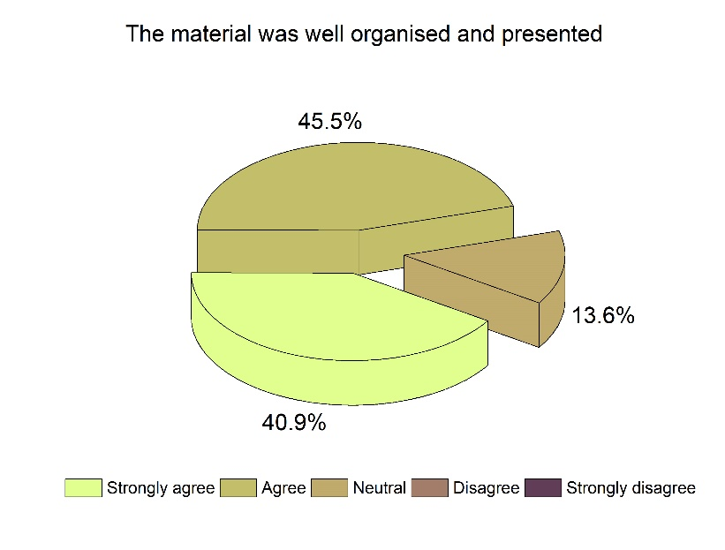
Fgiure 1.1a. Percent of delegates agreeing that the Summer School had clear objectives | Figure 1.1b. Percent of delegates agreeing that the Summer School materials were well organisaed and presented.
The training school agenda and further details are available on the project website (http://odysseaplatform.eu/events/operational-oceanography-for-science-business-and-society/).
At the last CWG meeting in February 2019, the Second ODYSSEA summer was provisionally agreed for September 2020 and will be held in Tunisia.

- Task 11.5: Concluding conference has not been implemented yet.

What are the challenges that you foresee for the next 6 – 12 months within your WP?

- Maintaining the momentum of the Communication Working Group to ensure that the communication plan is fully implemented and effective
- Gathering sufficient material from other work pages to fully communicate all outputs

What inputs are you expecting from other WPs and when?

- Continued partner / work package leader engagement with the “Tweet per Month” campaign (all work packages) - Monthly
- ODYSSEA Platform information and products to enhance the website content and look (WPs 6,7,8, 9) as the ODYSSEA platform is launched and definition of the business use cases - 2019
- Continued input into the events register to help coordinate communication at all events (all work packages)
- Project updates, products, and news via the website and social media campaigns (all work packages)

What outputs are you expecting to provide to other WPs and when?

- Series of graphical products giving an overview of the project and the ODYSSEA Platform targeting a variety of end users (all work packages) (On-going)
- Continued updates on the project activities, progress and news via the projects website and Social Media campaign (all work packages).
- Series of graphics outputs (both print and online) for ODYSSEA products.
- Revision to the look / feel of the ODYSSEA website.

